**CHAPTER - 1**

**INTRODUCTION**

The success of communication network has largely been a result of adopting a layered architecture. With this architecture, its design and implementation divided into simpler modules that are separately designed and implemented and then interconnected. A protocol stack typically has five layers, application, transport (TCP), network (IP), data link (include MAC) and physical layer. Each layer controls a subset of the decision variables, hides the complexity of the layer below and provides well-defined services to the layer above. Together, they allocate networked resources to provide a reliable and usually best-effort communication service to a large pool of competing users.

Do you know this? Sometimes work just isn't happening and the underlying problem is unclear. Normally you would spend hours searching in the depths of the process landscape, but there is a much simpler and more effective method: Process miningwith the help of this technology, real workflows are compared with theory, which leads to better transparency as well as insight into the processes. This is necessary because the reality of the processes usually does not correspond to the ideas of the process participants and the work steps in reality are usually much more complex. You can imagine this like the promo pictures of empty vacation beaches, which are then totally overcrowded in reality.

Process mining is a process management technique. It aims to discover, monitor and improve process flows by extracting readily available knowledge from information systems event logs. Process mining provides companies with complete visibility into how processes really work. With these insights, companies can then identify opportunities for process optimization.

* 1. **Modules**

# **1.1.1** **PROCESS MINING**

In this module we learned how to:

* **Data transformation**
* **Data analysis**
* **Continuous monitoring**

# **1.1.2 process mining(cloud)**

In this module we learned how to:

* **App templates**
* **Extracting and loading data**

**1.1.3 Processes Mining transparency**

In this module we learned how to:

* **Automation Process Discovery**
* **Conformity Check**
* **Organization Mining**

**1.1.4 Process Mining is the MRI for processes**

In this module we learned how to:

* **MRI Technology**
* **Risk of Confusion**

**1.1.5 Mining Algorithm**

In this module we learned how to:

* **Deterministic Algorithm**
* **Heuristic Algorithm**
* **Genetic Algorithm**
  + 1. **Starting a Project in mining**

In this module we learned how to:

* **Determining problem**
* **Defining the Data**
* **Pilot Project**
* **Accepting Truth**

**1.1.7** **Industrial Usage of Mining**

In this module we learned how to:

* **Production**
* **Financing**
* **Telecom**

**1.1.8 Process Mining Software’s**

In this module we learned how to:

* **Process Detection**
* **Conformity Testing**
* **Performance Analysis**

**1.1.9 Software Key Functions**

In this module we learned how to:

* **Identifications**
* **Optimization**

**1.1.10 Process Mining Software Providers**

In this module we learned how to:

* **Different Software Providers**

**CHAPTER - 2**

**TECHNOLOGY**

**Process Mining Technologies**

Process mining applies data science to discover, validate and improveworkflows. By combining data mining and process analytics, organizations can mine log data from their information systems to understand the performance of their processes, revealing bottlenecks and other areas of improvement.

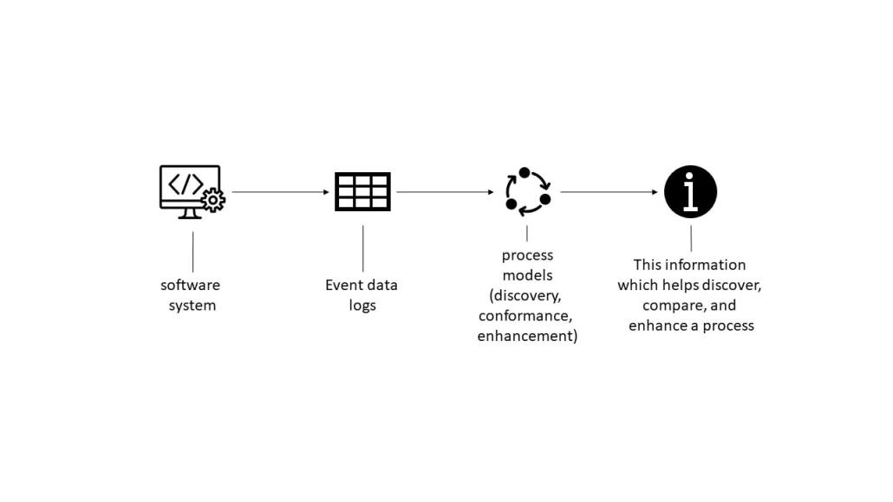

**Fig.No.2.1: Process mining technology**

1. **App templates**

With the **Process Mining** service in Automation Cloud, you can create new process apps based on process-specific app templates. An app template contains a predefined set of dashboards and KPIs for process analysis and can be used as the starting point for creating your process apps. If available, an app template can include a built-in connector for a specific combination of a process and source system.

1. **Extracting and loading data**

When creating a process app, you can upload data from .csv or .TSVfiles, or you can set up a connection to a source system using the extraction tools C Data Sync or Theobald Xtract Universal. You can also use **data bridge agent** to use custom. MVP connectors to upload data from your source system.

1. **Editing data transformations**

Transformations are applied to the data stored in the database to make sure the data adheres to a data schema which can be loaded in the **Process Mining** process app. In **Process Mining**, you can customize the transformations to adapt them to your data schema.

1. **Customizing process apps**

After creating a process app from an app template, you can edit the dashboards to customize the process app to your business needs. The **Dashboard editor** provides various options to create different views, and to organize, group, and filter data.

The **Data Manager** enables you to customize the data used in your process app. With **Data Manager** you can edit data fields and metrics to change the display names used in your app. Besides, you can toggle fields to be visible or not.

1. **Root cause analysis**

With **Root cause analysis**, you can compare the influence of case properties on a certain behavior to find significant data influencers for specific process situations. A set of cases is defined based on the period filter. This selection is called Reference cases. Within this set of cases, you can select the behavior that you want to analyze.

1. **Managing access control for process apps**

The **Admin Console** module enables you to manage access by assigning roles to users or groups. The permissions model allows you to integrate all your employees using **Process Mining** based on your business requirements

## CHAPTER - 3

## APPLICATIONS

Process mining applies data science to discover, validate and improve workflows. By combining data mining and process analytics, organizations can mine log data from their information systems to understand the performance of their processes, revealing bottlenecks and other areas of improvement. Process mining is beneficial for many situations in large organizations. Areas where process mining can be actively applied include the following

* Automation This is about understanding the actual processes, variations and opportunities to be successful in RPA projects.
* The reporting of complete process KPIs and dashboards for a given process.
* The Digital Transformation to understand the "big picture" - how businesses operate, what needs to be prioritized and transformed.
* Scaling optimization efforts across multiple business operations and locations and supporting process control through the use of Data.
* Capture processes anywhere in the enterprise with little human effort.
* Identify bottlenecks, deviations, and inefficient processes to be reconsidered or automated.
* Continuous monitoring and measurement of improvements.
* Simplify compliance, with complete audit trails.
* Delivering the full context and end-to-end perspective required for process improvements.
* Identify the most valuable and effective processes for using automation.

# **CHAPTER - 4**

**MODULES EXPLANATION**

**Module 1: Process Mining**

Process mining applies data science to discover, validate and improveworkflows. By combining data mining and process analytics, organizations can mine log data from their information systems to understand the performance of their processes, revealing bottlenecks and other areas of improvement. Process mining leverages a data-driven approach to process optimization, allowing managers to remain objective in their decision-making around resource allocation for existing processes. Process mining focuses on different perspectives, such as control-flow, organizational, case, and time. While much of the work around process mining focuses on the sequence of activities control-flow—the other perspectives also provide valuable information for management teams.

**Module 2: Process Mining Cloud**

With the **Process Mining** service in Automation Cloud, you can create new process apps based on process-specific app templates. An app template contains a predefined set of dashboards and KPIs for process analysis and can be used as the starting point for creating your process apps. If available, an app template can include a built-in connector for a specific combination of a process and source system. offers out-of-the box app templates for several processes and source systems that you can use as the starting point for creating your process apps. You can customize these app templates to your business needs and publish them with a set of dashboards and KPIs to enable business users to monitor and analyze the processes in detail. When creating a process app, you can upload data from .csv or .TSV files, or you can set up a connection to a source system using the extraction tools C Data Sync or Theobald Xtract Universal. You can also use **Data Bridge Agent** to use custom. MVP connectors to upload data from your source system.

**Module 3: Processes Mining transparency**

Process mining is a process management technique. It aims to discover, monitor and improve process flows by extracting readily available knowledge from information systems event logs. Process mining provides companies with complete visibility into how processes really work. With these insights, companies can then identify opportunities for process optimization. Process mining involves several steps.

The automated process discovery - extraction of process models from an event log.

&

The conformity check - monitoring deviations by comparing model and protocol.

**Module 4: Process Mining is the MRI for processes**

Process mining technology could also be compared to magnetic resonance imaging (MRI) technology, which collects information from the body's cells to create an image - only in a business environment. Doctors then use this MRI image to diagnose health conditions. Process mining works on a similar principle: It collects data from the smallest part of process activities and assembles it into a picture that companies can use to diagnose the state of their workflows. Process mining is changing the way companies operate and manage their business operations. In their quest for process quality, companies can use process mining to really get to know their process, evaluate it against the ideal process model, and optimize it as needed.

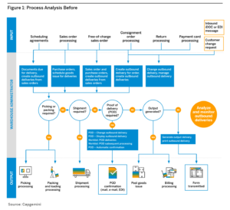

**Fig.No.4.1: Process Mining MRI**

**Module 5: Mining Algorithms**

The mining algorithm determines how process models are created. The best own categories are:

**1.Deterministic Algorithm:** Determinism means that an algorithm produces only defined and reproducible results. It always delivers the same result for the same input.

The deterministic algorithm was one of the first algorithms capable of handling concurrency. It takes an event log as input and computes the order relation of the events contained in the log.

**2.Heuristic Algorithm:** Heuristic mining also uses deterministic algorithms. However, they refer to the frequency of events and traces to reconstruct a process model. A common problem in process mining is that real-world processes are very complex and their discovery leads to complex models. This complexity can be reduced by neglecting rare paths in the models.

**3.Genetic Algorithm:** They use an evolutionary approach that mimics the process of natural evolution. They are not deterministic. Genetic mining algorithms follow four steps: Initialization, Selection, Reproduction, and Termination.





**Fig.No.4.2: Mining Algorithms**

**Module 6: Starting Project in Mining**

To start a project in the stream of process mining one need to follow some

basic requirements they are classified as follows.

**Determine Problem**: Identify the problem of importance to the business that can realistically be addressed with process mining.

**Identify the Data**: Identify the data sources that need to be fully understood to address the business process issues under consideration

.

**Setting Pilot Project**: Set up a pilot project to prove the potential value of a process mining solution.

**Accept Truth**: Accepting the results of the analysis, as process mining provides, among other things, a clear picture based on facts.

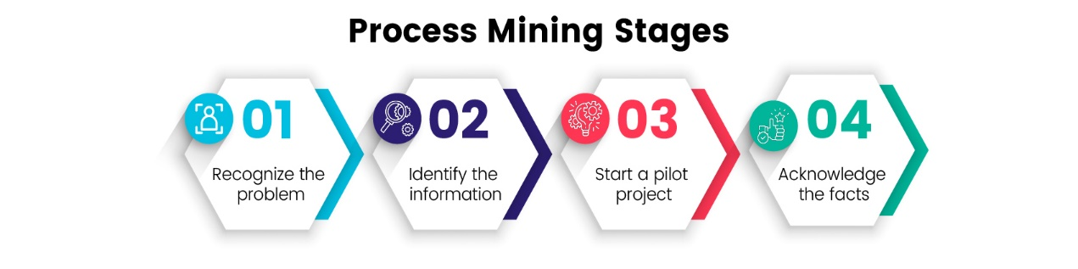

**Fig.No.4.3: Mining Projects**

**Module 7: Industrial Usage of Mining**

**Production**

In the manufacturing industry, timely and accurate delivery to a customer is the goal. When a company has multiple factories in different regions, there are usually differences between the reliability of deliveries. It is fairly easy to see that they exist, but it is more difficult to understand exactly where or why they are happening. Process mining can be used to compare the performance of different locations, down to individual process steps, including duration, cost, and the person performing the step. All event data available in the systems is suitable for use. In this way, facts can be generated.

**Banking and finance**

In the financial sector, it is important to comply with rules and regulations and to be able to provide evidence of this. By using the event data from the systems, individual cases can also be visualized as a process flow. It can be shown how often

**Telecommunication**

Telecommunications is a highly competitive sector worldwide. The ability to improve operational processes is key to success and profitability. Process mining helps telecom companies gain visibility into geographically dispersed operations, identify bottlenecks, and ensure that customers receive products and services on time

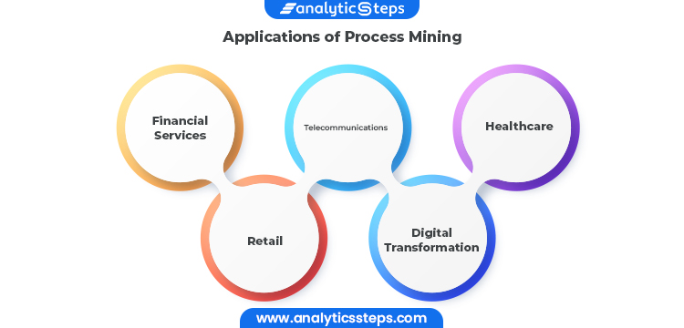

**Fig.No.4.4: Industrial uses of mining**

**Module 8: Process Mining Software’s**

A process mining solution should have strong detection capabilities. It should be able to search event logs to track what employees are actually doing and then create an appropriate process model by generating process maps of the entire business flow.In addition, the solution should have robust conformance checking that analyzes event logs to ensure that actions match process models. Third, a process mining solution needs performance analysis and improvement capabilities that analyze potential inefficiencies within an event log to determine if and how they can be improved, and then make improvements based on real process data. Ultimately, though, which software is right for the job depends on the size of the company, its business needs, and its goals.

**Module 9: Process Mining Software Key Functions**

If your selected process mining software fulfills these key functions, then you have already made a good choice. However, you should always keep in mind that your company's ability to measure, monitor and optimize business processes has a direct impact on revenue and customer satisfaction. Therefore, it is important to choose the right process mining solution wisely to ensure that all business goals are optimally met. If necessary, an expert can also be consulted. Identify bottlenecks & process optimization opportunities Provide insights into failed process steps Ensure end-to-end view of the entire process Monitor performance indicators in real time Perform data cleansing Compliance analysis & gap analysis Provide continuous business process monitoring in real time Improve process model.

**Module 10: Process Mining Software Providers**

**The following are the Process Mining Software Providers in the Market**

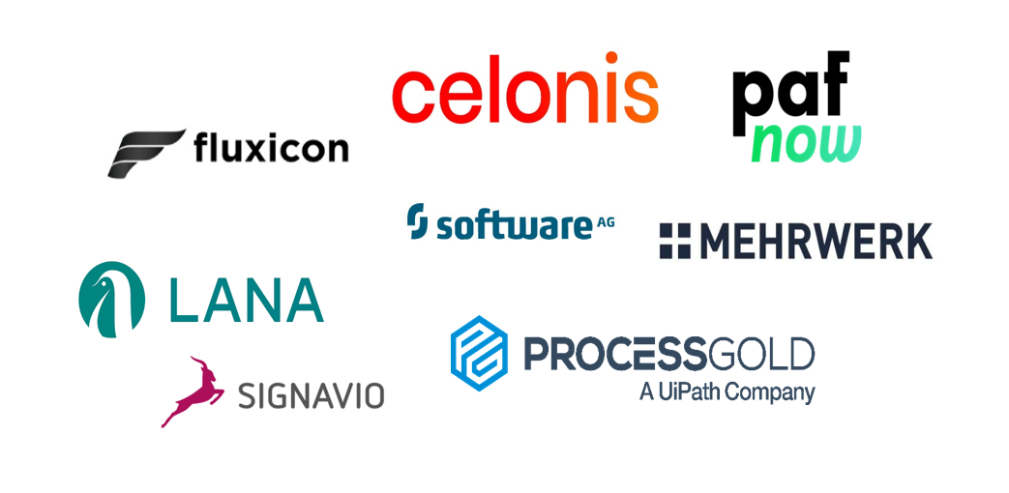

**Fig.no.4.5: Software providers**

# **Chapter 5**

# **APPLICATIONS**

Applications of process mining involve using process mining techniques to analyze and improve processes as they occur, providing insights and interventions in real-time. Here are some examples of real-time applications of process mining:

* **Operational Monitoring and Alerts**: Process mining can be used to monitor ongoing processes in real-time and generate alerts when deviations or anomalies are detected. This allows organizations to take immediate action to address issues and maintain process efficiency.
* **Dynamic Resource Allocation**: In scenarios where resources need to be allocated dynamically, such as in manufacturing or service industries, real-time process mining can help optimize resource allocation based on the current state of the process and demand.
* **Customer Support and Service**: Real-time process mining can analyse customer support interactions and service processes as they happen. It helps identify areas where customer queries are getting delayed, allowing support teams to intervene promptly and provide timely assistance.
* **Supply Chain Visibility:** Monitoring supply chain processes in real-time using process mining can provide visibility into the movement of goods, inventory levels, and potential disruptions. This enables organizations to respond quickly to changes in demand or supply.
* **Healthcare Patient Pathway Optimization:** In healthcare settings, real-time process mining can analyse patient pathways, identify delays, and optimize the allocation of medical resources to ensure timely patient care.
* **Energy Management:** Real-time process mining can be applied to monitor energy consumption patterns in buildings or industrial processes. It helps in identifying energy wastage and suggesting real-time adjustments to optimize energy usage.
* **Fraud Prevention:** In financial transactions, real-time process mining can detect unusual patterns or behaviours that might indicate fraudulent activities. Immediate alerts can be triggered for further investigation.
* **IT Incident Management:** Real-time process mining can be employed to monitor IT incidents and responses in real-time. This ensures that IT teams can quickly address and resolve issues to minimize service disruptions.
* **Logistics and Transportation Optimization:** For logistics and transportation companies, real-time process mining can track the movement of goods, optimize routes, and adapt to changing conditions on the road for efficient deliveries.
* **Emergency Response Management:** During emergency situations or crisis events, real-time process mining can help organizations manage response processes effectively by identifying bottlenecks, allocating resources, and adapting to changing conditions.
* **Retail Operations:** In retail, real-time process mining can track in-store customer movements, analyse checkout processes, and optimize staff allocation based on real-time foot traffic.
* **Manufacturing Process Control:** Real-time process mining can monitor manufacturing processes, identify deviations from optimal conditions, and trigger adjustments to maintain quality and efficiency.

These examples highlight how real-time process mining can provide valuable insights and enable organizations to make informed decisions and interventions on the fly, ultimately improving operational efficiency, customer satisfaction, and resource utilization

# **Chapter - 6**

# **LEARNING OUTCOMES**

* Gain an overall understanding of basic Process Mining concepts.
* Become familiar with Mining core services and tools.
* Learn the architectural principles of the process Mining.
* Understand and be able to explain Process Mining and compliance measures.
* Understand the Process Mining budget and pricing philosophy.

# **CONCLUSION**

* By doing this internship we learnt
  + The importance of Process Mining.
  + Tools that help us to optimize our service costs.
  + Software Production and Estimation.
  + Processing the Huge data.
  + And other different Services that are provided in Mining.

Process mining is a powerful methodology that offers organizations valuable insights into their operational processes, enabling them to enhance efficiency, compliance, and overall performance. It was a valuable experience. It helped to identify, where improvements could be made to make things run smoother and more efficiently. This internship taught me practical skills, like working with data and collaborating with different experts. Overall, it was a great opportunity to learn and contribute to making processes better.

# 

## REFERENCES

* The Reference of this internship was done in the celonis platform link

https://academy.celonis.com/learn/dashboard

* Introduction to process mining

-https://academy.celonis.com/learn/course/introduction-to-process-mining/intr

oduction-to-process-mining/course-outline?client=academic-alliance-celonis

* Process mining fundamental

-https://academy.celonis.com/learn/learning-path/process-mining-fundamenta

ls-for-students

